AUTOMATION TESTING

**Research on Automation Testing Tools**

| **Submitted By:** | **Submitted To:** |
| --- | --- |
| **Nischal Shrestha** | **Prajesh Shakya** |

**Date: 16th May, 2025**

# ABSTRACT

This report provides a comprehensive overview of Automation Testing, a critical practice in modern software development and quality assurance. The report outlines the fundamental workflow of automation testing, including tool selection, scope definition, test scripts development, execution, and ongoing maintenance. It also explores various types of tests that can be automated such as regression, smoke, functional, etc.

# TABLE OF CONTENTS

**ABSTRACT 2**

**TABLE OF CONTENTS 3**

**AUTOMATION TESTING 3**

Introduction 4

How Automation Testing works? 4

Automation Testing Life Cycle 5

Types of Automation Testing 7

When to Use Automation Testing 9

Test Automation Strategy 10

Benefits of Automation Testing 10

Automation Testing Frameworks 11

Challenges and Considerations 11

# AUTOMATION TESTING

## Introduction

Automation Testing is the use of software tools and scripts to automate the execution of tests in software development and quality assurance processes. This method aims to increase efficiency and effectiveness by reducing human errors, saving time, and improving test coverage. Automation Testing can be applied to various types of tests, including unit, API, regression, and user interface tests.

Automation Testing offers several benefits, such as faster execution of tests, higher reliability due to reduced human error, and cost-effectiveness in the long run. It is particularly useful for repetitive tasks like regression testing and can be integrated into continuous integration (CI) and continuous delivery (CD) practices to ensure that new code is error-free and ready for deployment quickly.

However, automation testing requires initial investment in tools and skilled automation engineers, and it may not be suitable for exploratory testing or applications with frequently changing user interfaces. It is important to consider the specific needs of the system under test (SUT) and the types of tests required when deciding whether to automate certain tests.

Automation Testing can be performed using various frameworks and tools, such as Selenium, Robotium, and Cypress, which support different programming languages and platforms. These tools can help manage test scripts and provide detailed test reports, enhancing the overall testing process.

In summary, Automation Testing is the process of using specialized software tools and scripts to automatically execute tests on software applications, with the goal of validating functionality, ensuring requirements are met, and identifying defects before release-all with minimal or no human intervention.

## How Automation Testing works?

The typical automation testing workflow involves:

1. Choose the Right Tool: Selecting a testing tool that aligns with the project requirements and is compatible with your chosen platforms is essential. Consider factors like ease of use, scalability, and support for various testing types.
2. Scope Definition: Clearly define the scope of your automation testing efforts. Identify specific functionalities and areas within your application that will benefit most from automation. This focused approach ensures efficient use of resources.
3. Strategize, Design, Develop: Develop a comprehensive strategy highlighting the testing scope and objectives. Design your automation framework with a focus on reusability and maintainability. Implement the automation scripts, keeping the chosen functionalities in mind.
4. Integration with CI/CD: Consider integrating your automation tests into a Continuous Integration/Continuous Deployment (CI/CD) pipeline for seamless and automated testing during the development lifecycle.
5. Test Execution: Execute your automated tests to ensure comprehensive coverage of the defined scope. Closely monitor the test runs to guarantee precise and accurate outcomes. Promptly address any issues or failures and refine your scripts as needed.
6. Continuous Maintenance: Automation suites require ongoing maintenance to adapt to software changes and improvements. Regularly update and enhance your automation suite to align with evolving project requirements. This ensures the longevity and effectiveness of your automation testing efforts.
7. QA metrics and Reporting: Implement metrics and reporting mechanisms to track the performance of your automation tests. This provides valuable insights into your testing strategy's effectiveness and helps identify improvement areas.

## Automation Testing Life Cycle

The Automation Testing Life Cycle (ATLC) is the process of automating the testing of software applications. It involves planning, designing, executing, and analyzing automated tests to ensure the software meets its requirements.

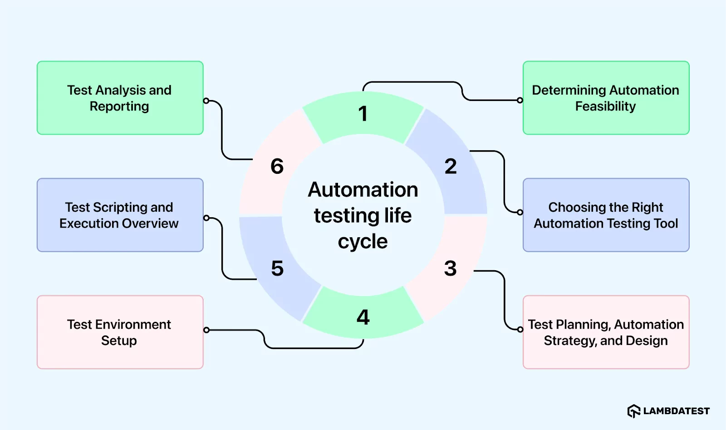

Fig: Automation Testing Life Cycle

1. Determining Automation Feasibility: This stage involves evaluating whether automation is suitable for the project. Factors such as the project's duration, budget, and the frequency of testing are considered to determine if automation will be beneficial.
2. Choosing the Right Automation Testing Tool: Once it's decided to automate, the next step is to select the appropriate automation tool. This involves considering factors like compatibility with the application, ease of use, and cost.
3. Test Planning, Automation Strategy, and Design: In this stage, a detailed plan for automation is created. This includes defining objectives, identifying test scenarios to automate, and designing the overall automation strategy. Test scripts are planned and designed during this phase.
4. Test Environment Setup: Setting up the test environment involves configuring the hardware, software, and network settings required for running automated tests. It's important to ensure that the test environment closely resembles the production environment for accurate testing results.
5. Test Scripting and Execution Overview: Test scripting involves writing scripts or code to automate test scenarios. This step includes recording test steps, enhancing scripts with validations and conditions, and organizing them into test suites. Tests are then executed to validate the functionality of the application.
6. Test Analysis and Reporting: After the tests are executed, the results are analyzed to identify defects and areas for improvement. Detailed reports are generated to document the test results, including pass/fail status, error messages, and any deviations from expected behavior. These reports help stakeholders make informed decisions about the quality of the software.

## Types of Automation Testing

Automation can be applied to a wide range of testing activities, including:

1. Regression Testing: ensures new code changes don’t break existing functionality

It aims to safeguard existing functionalities by detecting any unintended impacts of recent code modifications. By retesting previously implemented features, it helps maintain the stability and consistency of the software, preventing regression errors.

1. Smoke Testing: quickly checks major functionalities in new builds

It is a preliminary assessment that determines whether fundamental functionalities of the software are operational. It serves as a quick check to ascertain the readiness of the system for further testing, providing an initial indication of its stability and usability.

1. Load Testing: assesses software performance under expected user traffic to find bottlenecks and ensure system stability and speed

This type of testing evaluates the performance of a software application under anticipated user loads. By simulating real-world usage scenarios, it helps identify potential performance bottlenecks and ensures optimal system scalability and responsiveness.

1. Stress Testing: pushes software to its limits under extreme conditions to reveal vulnerabilities and ensure robustness against failure

It assesses the resilience and stability of the software under extreme conditions, such as high user loads or resource limitations. By pushing the system to its limits, developers can uncover vulnerabilities and address potential failure points, enhancing overall robustness.

1. GUI Testing: examines the graphical user interface for usability, functionality, and consistency to ensure a positive user experience

It focuses on scrutinizing the graphical user interface for usability, functionality, and consistency. By evaluating the user experience and interface design, developers can identify and rectify any issues that may affect user interaction and satisfaction.

1. API Testing: validates APIs for functionality and reliability

It validates the reliability, functionality, and security of the application programming interface (API). By testing API endpoints and interactions, it ensures seamless communication between different software components and external systems, enhancing interoperability and data integrity.

1. Security Testing: identifies vulnerabilities and security gaps

It is crucial for detecting vulnerabilities and ensuring the protection of sensitive data. By identifying potential security loopholes and vulnerabilities, developers can mitigate risks and safeguard against potential security breaches, aligning with industry standards and user expectations.

1. Unit Testing: tests individual components or units of code

This is a crucial phase that focuses on maintaining code integrity by carefully examining its smallest units in isolation. It ensures that individual components of the software function as intended, enhancing overall quality and reliability.

1. Integration Testing: verifies that different software components work together seamlessly to ensure the system functions correctly as a whole

It evaluates the seamless interaction and integration of various software components. By validating the functionality of interconnected modules, it ensures the smooth operation of the system as a whole, mitigating potential integration issues.

1. Functional Testing: verifies that features work as intended

It involves assessing software features against predefined requirements to ensure alignment with intended functionality. By rigorously testing each function, developers can verify that the software meets user expectations and performs as intended.

1. Performance Testing: assesses speed, stability, and scalability under load

It is a type of software testing that assesses how well a system performs in terms of its speed, stability, and scalability when subjected to various workloads (i.e. user activity or data volume). It helps identify bottlenecks, ensure the system can handle expected (and sometimes unexpected) usage, and ultimately provides a smooth and responsive user experience.

1. Data-driven Testing: runs tests with multiple data sets

This testing approach where test cases are executed using various sets of input data, rather than hardcoding the data directly into the test script. This allows for more efficient and thorough testing by running the same test logic with different values, covering a wider range of scenarios and reducing test script redundancy.

1. UI Testing: checks that user interface elements function correctly

It is a type of software testing that focuses on verifying that all visual and interactive elements of a software application’s user interface (like buttons, menus, forms, text fields, etc) function as expected and are displayed correctly. It ensures that the user can effectively interact with the application and that the interface responds appropriately to their actions.

1. Acceptance Testing: confirms the software meets business and user requirements

It is the final stage of software testing where the software is validated against the initial business requirements and user needs to ensure it’s ready for deployment and meets stakeholder expectations.

## When to Use Automation Testing

Automated testing is strategically used in the software development lifecycle to enhance efficiency, identify defects promptly, and ensure the reliability of applications. Knowing when to implement automated testing to maximize its benefits and streamline the testing process is crucial. It is essential to consider the following factors while selecting which tests to automate:

1. Repetitive and time-consuming test cases: Automation is a good option for tests that demand a lot of manual work and repetition. These tests can be automated to save time and lower the possibility of human error.
2. Crucial test cases for business: Automation is well-suited for tests essential to the company's operation, such as the checkout process or the add-to-cart function in an e-commerce website. Ensuring the smooth functioning of these processes is critical for preventing user disruptions on the website. By automating these tests, their execution becomes more reliable and consistent, contributing to a seamless user experience.
3. Complex test cases: Automating a big test script on different network conditions can lower the possibility of mistakes and ensure the tests are carried out correctly.
4. Data-driven tests: Automation is an excellent option for tests that need a lot of data input and output. Automating these tests can make the data accurate and consistent throughout numerous runs. For example, data entry actions are recorded and entered into an application form. Only the values you entered during the recording are included in the test and will not lead to errors in the application. However, other data might throw errors. In this case, automating the tests is valuable to support the accuracy of results.
5. Stable test cases: Tests operating in a predictable and steady environment are suitable candidates for automation. The execution of these tests can be made more dependable and accurate by automating them. A familiar example of a stable test case is a CPU test. It examines the stability of the CPU and keeps track of how it performs as the workload rises.

Choosing the proper tests for automation is crucial to ensure that the effort is productive and efficient and adds the maximum value to the business. Software development teams can select the tests best suited for automation by considering these factors and developing a solid and effective strategy.

## Test Automation Strategy

Test Automation Strategy serves as the blueprint for implementing automated testing effectively within an organization or project. It includes careful planning and decision-making processes, including the identification of suitable test cases for automation, the selection of appropriate tools and technologies, and the establishment of robust practices for test maintenance and management. A well-crafted strategy ensures that automated testing aligns seamlessly with the software development life cycle (SDLC) enhancing efficiency, reducing time-to-market, and elevating overall product quality. By embracing a comprehensive automation strategy, teams can confidently navigate complexities, streamline resource allocation, and attain enduring success in their software testing endeavors.

## Benefits of Automation Testing

Automation Testing offers significant advantages:

1. Speed: automated tests run much faster than manual tests, enabling rapid feedback and faster release cycles
2. Accuracy: reduces human error by executing tests consistently
3. Increased Test Coverage: allows more scenarios and platforms to be tested, improving software quality
4. Cost Savings: Minimizes manual effort, reducing long-term testing costs
5. Early Bug Detection: catches defects early in the development process, saving time and resources
6. Resource Optimization: frees testers to focus on complex and exploratory testing rather than repetitive tasks
7. Scalability: tests can be run 24/7 across multiple environments and devices

## Automation Testing Frameworks

Automation Testing is often structured using frameworks to improve maintainability and scalability:

1. Keyword-Driven Framework: uses keywords to represent actions
2. Data-Driven Framework: runs tests with multiple data sets
3. Hybrid Framework: combines multiple approaches
4. Modular Framework: breaks tests into reusable modules

## Challenges and Considerations

While automation testing delivers many benefits, it also presents challenges:

1. Initial Investment: Requires time and resources to set up tools, frameworks, and scripts
2. Maintenance: Automated tests must be updated as the application changes
3. Not a Replacement for Manual Testing: Some exploratory, usability, and ad-hoc tests still require human judgment
4. Test Case Selection: Not all tests are suitable for automation; repetitive and high-value tests are prioritized

# CONCLUSION

Automation Testing is a valuable practice in modern software development. By automating repetitive and critical tests, organizations can achieve faster feedback, improved accuracy, and greater test coverage. This leads to earlier bug detection, reduced costs, and accelerated release cycles. While careful planning, tool selection, and ongoing maintenance are essential, the strategic use of Automation Testing, within a well-defined framework, empowers development teams to deliver more reliable and robust software, ultimately increasing efficiency and customer satisfaction.